**RGB Optical Flow**

**EECS 581 Group 1**

**November 2022**

Optical flow or optic flow is the pattern of apparent motion of objects, surfaces, and edges in a visual scene caused by the relative motion between an observer and a scene. It can also be defined as the distribution of velocities of movement of brightness pattern in an image. With videographic data, optical flow refers to the apparent motion of individual pixels on the image plane. Applications range from motion detection and motion compensated encoding to object segmentation and time-to-contact information.

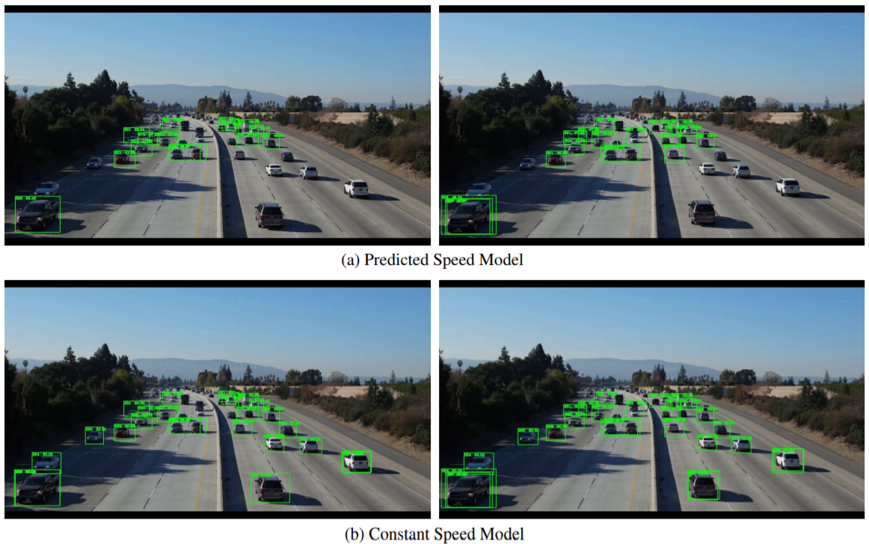

Optical flow provides a concise description of both the regions of the image undergoing motion and the velocity of motion. Optical-flow methods are based on computing estimates of the motion of the image intensities over time in a video. Area correlation optical flow for example, works by pairing points in one image to points in the next (i.e., points in the different frames of a video). Point matching is done by comparing intensities within a given window, and pairing points that have the smallest difference in intensity. Once points have been paired, the velocity is calculated as the distance that the point has moved.

The researchers whose work influenced ours made use of the optical flow of the subjects’ hands to match the optical flow on pre-trained signs. They obtained optical flow features by utilizing the TVL1 algorithm implemented with OpenCV and CUDA. They cropped and resized RGB and optical flow frames to 256×256 based on the keypoints obtained from whole-body pose estimation. During training, they randomly sampled 32 consecutive frames for each video. When testing, they uniformly sampled 5 such clips from input videos and averaged their predicted score.

Figure 1: Optical flow data shown in image d

Of course, optical-flow-based techniques are computationally complex, and hence require fast hardware and software solutions to implement. Since optical flow is fundamentally a differential quantity, estimation of it is highly susceptible to noise; and dealing with that noise leads to an increase in complexity. Understandably, optical flow only contributes when the sign is meant to have motion (e.g., letter j or z). It might even affect the accuracy of detection of stationary signs by detecting irrelevant factors in the video stream (hand shake, background motion, body sway, etc). We will have to give a lower weight to the optical flow prediction as the researchers mentioned above did, but the data might come in useful when we begin to implement a wider range of signs that involve motion.

**Sources:**

https://github.com/jackyjsy/CVPR21Chal-SLR#Pretrained-Models

https://nanonets.com/blog/optical-flow/

https://www.geeksforgeeks.org/python-opencv-dense-optical-flow/

https://en.wikipedia.org/wiki/Optical_flow

<https://www.sciencedirect.com/topics/engineering/optical-flow>

jiang2021sign, Sign Language Recognition via Skeleton-Aware Multi-Model Ensemble, Jiang, Songyao and Sun, Bin and Wang, Lichen and Bai, Yue and Li, Kunpeng and Fu, Yun, 2021